Name: Maryam Azhar

Sap ID: 43755

BSCS-6

# **LAB 3**

**Task 1:** What is Ethernet cable? What type Ethernet cable is most commonly used in LAN network?

**Answer:** An Ethernet cable is used for wired network connections. It is used to provide internet connections and connects devices to network. The most commonly used type in LAN networks is **Cat5e**, which supports speeds up to 1 Gbps. For higher speeds and performance, **Cat6** or **Cat6a** cables are also commonly used.

**Task 2:** What is a LAN (local area network)? When and why to use LAN cable to sendfiles from one computer to another?

**Answer:**

LAN   
A LAN (Local Area Network) connects devices within a limited area, like a home or office. Use a LAN cable to send files between computers.

When and why to use LAN cable

Use a LAN cable to send files when you need high-speed transfers, such as for large files or extensive data. It's also useful for ensuring a stable and reliable connection, particularly if the wireless network is slow or unstable.

Use a LAN cable to send files for faster transfer speeds and more reliable connections compared to wireless. It also provides enhanced security and consistent performance.

**Task 3: How Does LAN Work? What is meant by 127.0.0.1 and localhost?**

**How Does LAN Work?**

**A Local Area Network (LAN) connects devices within a specific area, such as a home or office, using wired (Ethernet) or wireless (Wi-Fi) connections. Devices on a LAN can communicate with each other, share resources, and access the internet through a central router or switch.**

**What is 127.0.0.1 and Localhost?**

**127.0.0.1: This is the IP address used by a computer to refer to itself. It is commonly used for testing and troubleshooting network services on the local machine.**

**Localhost: This is a hostname that translates to the IP address 127.0.0.1. It refers to the local computer, allowing programs to communicate with each other.**

**Task 4: How two computers can share files through disk sharing.**

Answer:

Step: 1  
 Open file Explorer by Press Win+E to open File Explorer.

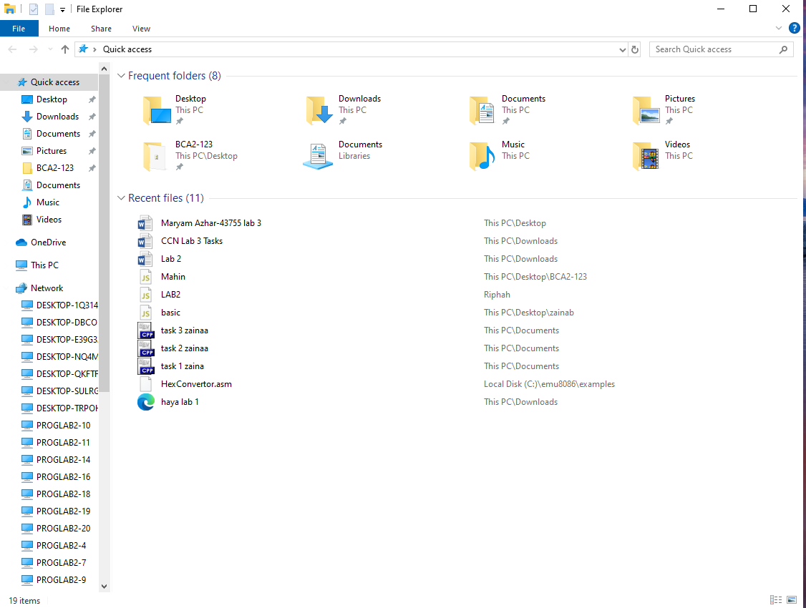

Step: 2  
 Select the drive to be shared. Right click and select properties

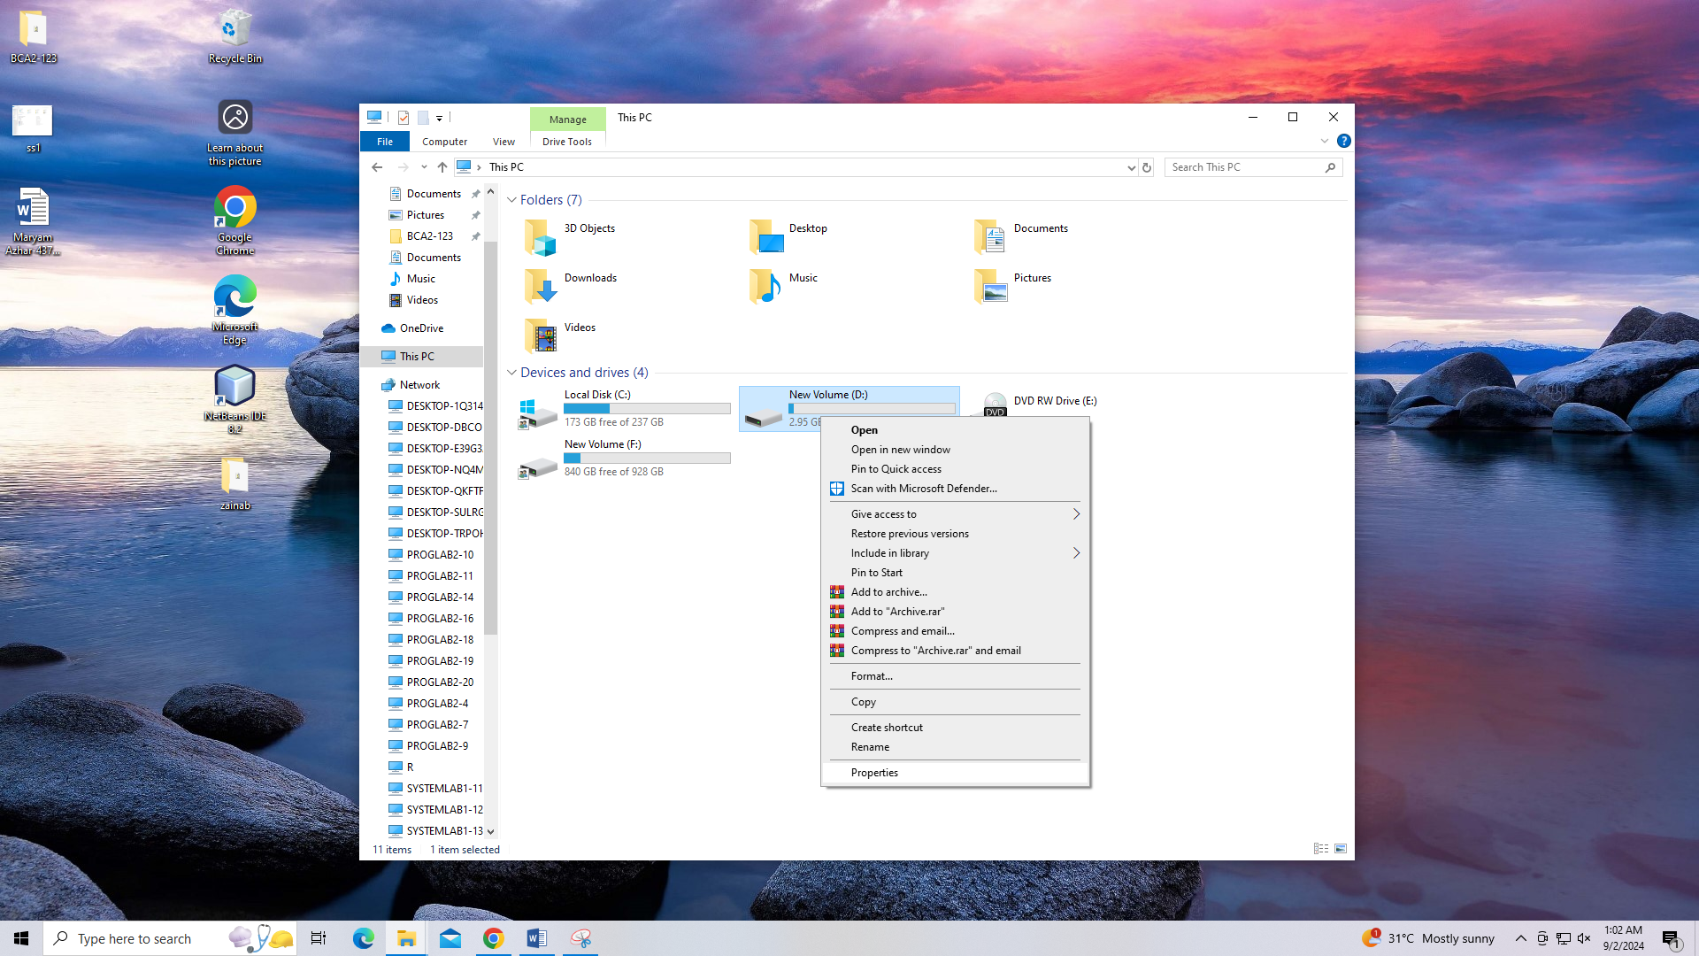

Step: 3

Go to sharing and click on advanced sharing  
 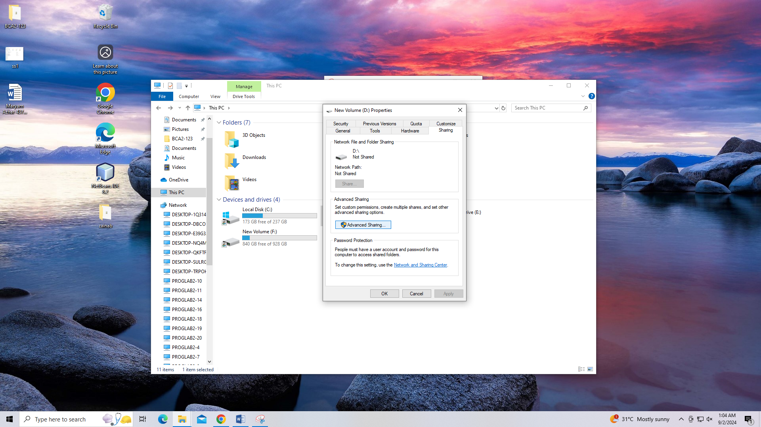

Step: 4

Enter the password and click the ‘share the folder’ check. Click on ‘Ok’

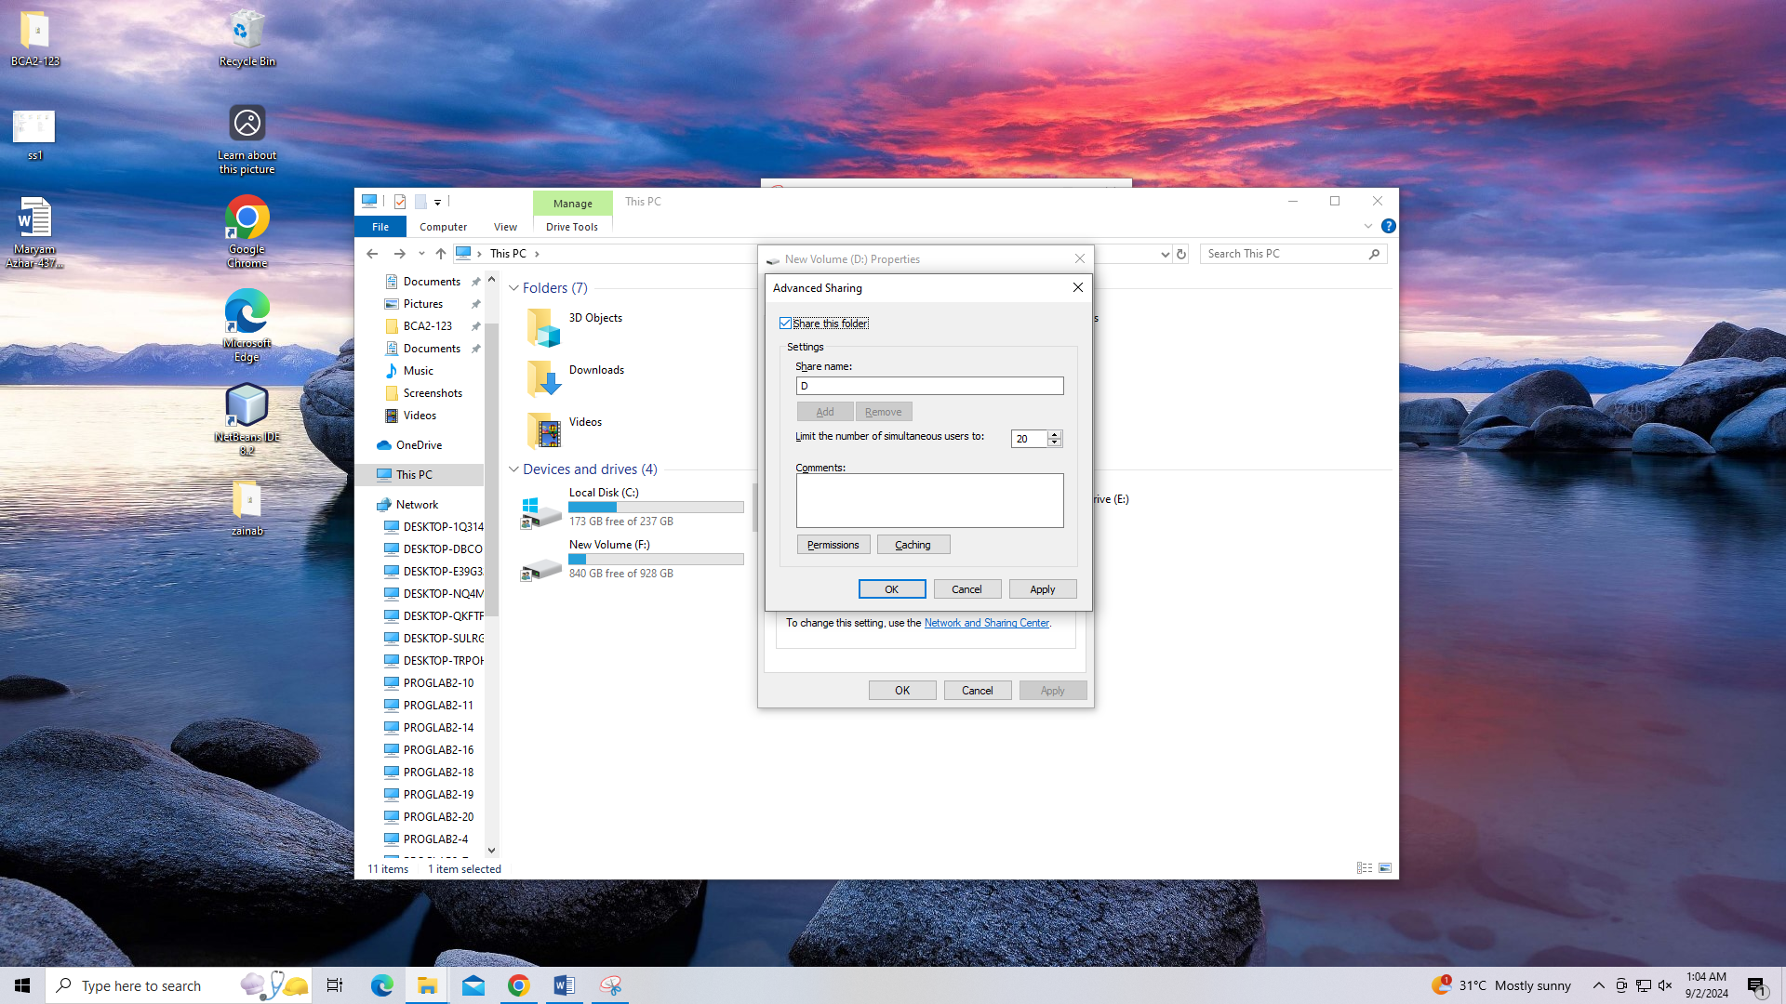

Step: 5

Go to Network and check the Network name.

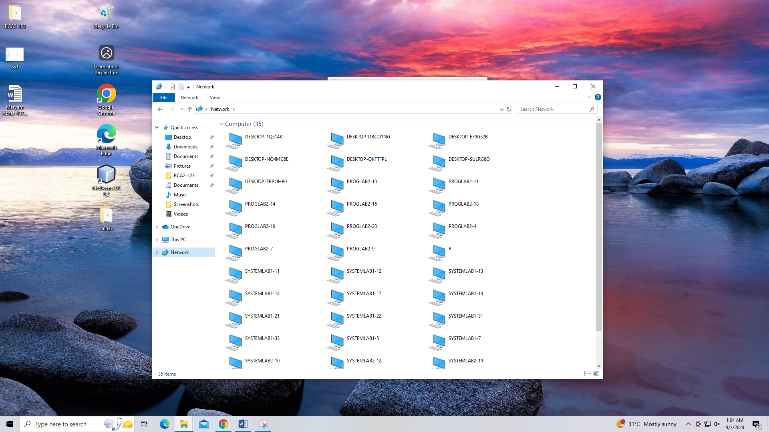

Another method to check the drive

Step 1: press ‘win + R’, and enter IP address of other document.

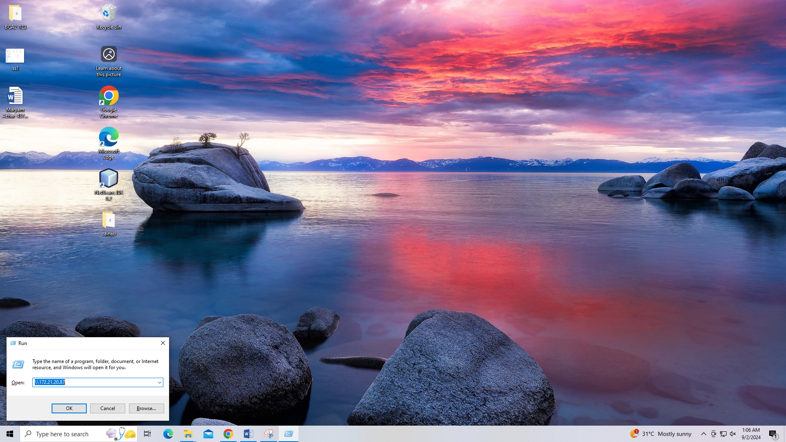

Step 2:

Check the name of document.  
